**MDF Rose Engine Lathe 2.0**

**with Stepper Motor Drive**



**Instructions for Building**

**Version 0.7**

**05 September 2020**

This document is intended to help one unfamiliar with the MDF rose engine to build one easily. It is designed to go with the kit you can purchase from [www.ColvinTools.com](http://www.ColvinTools.com).

There are some variations from the ideas documented by Jon Magill at [www.rogueturner.com](http://www.rogueturner.com/). Where this is the case, we have tried to document such changes and provide the reason for the change.

This document is also designed to use a stepper motor for driving the spindle.

If you have any questions, please contact us at [ColvinTools@Gmail.com](mailto:ColvinTools@Gmail.com).

Good luck.

Rich Colvin & Jack Zimmel

Table of Contents

Getting Started 4

Accuracy 4

The MDF for the Base and Headstock 5

Parts You Will Need 5

General Instructions 6

Lathe Headstock Instructions 7

Before Assembly 8

Assembly of the Headstock 15

After Assembly 16

Lathe Base Instructions 19

Before Assembly 21

Rubber Support 32

Assembly of the Base 35

After Assembly of the Base 35

Cross Slide Base Instructions 36

Drilling Holes and Assembly 38

# Getting Started

As you get started with building this machine, please consider making the machine exactly according to the outlined instructions. There are lots of ways you can modify this, and, quite frankly, the MDF rose engine encourages experimentation. But it is best to attempt those modifications after understanding how it works. Some ideas which sound grand may not appear so after understanding how the machine works (we speak from experience).

If you have any questions on the terminology in this document, check out the “Ornamental Turning Book of Knowledge” ([www.OTBoK.info](https://www.otbok.info/)).

Throughout this document, I’ve tried to show the MDF in its native color of tan/brown. There are differences in the images I captured from the CAD drawing made, but those are not representative of the machine’s differences. Unless otherwise noted, the MDF is ¾” thick.

## Accuracy

When making the MDF Rose Engine, there are certain aspects which must be managed for accuracy in the work.

### Headstock

1. The distance from the center of the rocking pivots to the center of the spindle should be 12 inches. The rosettes are designed around this.
2. The rocking pivot points need to be aligned with the spindle.

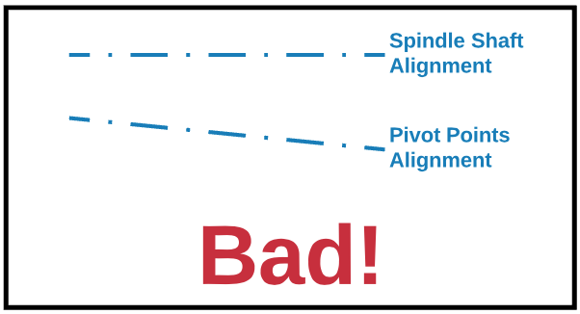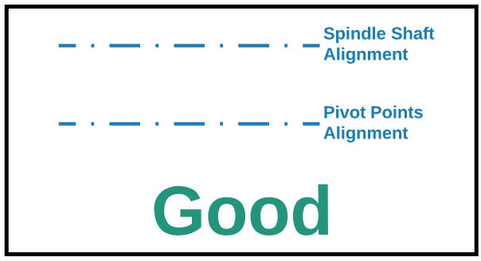

## The MDF for the Base and Headstock

The lathe’s base and headstock can be cut from a 4’ x 8’ sheet of MDF, or you can buy a kit with the pieces pre-cut.

| Package | Contents | Source(s) |
| --- | --- | --- |
| **MDF Rose Engine 2.0 MDF Kit** | * Pre-cut MDF pieces for the base and headstock. | The full kit is available from [ColvinTools.com](http://www.colvintools.com/)  You can also make your own using instructions below. |

If you choose to cut your own, you should be able to get a standard sized (8’ x 4’ x ¾”) piece of MDF from my local big-box store (Lowes). The default design from Jon Magill was to use 1/2 a sheet (4’ x 4’), but I’ve found a few pieces need to be different sizes than the original plan. It can all be obtained from a full sheet, with much to spare. Also, the extra material is useful for re-making parts if you mess up (or at least I did), and it is also useful for making some jigs and fixtures that are always useful around the shop.

One layout for cutting the pieces is shown below

(coming later …)

## Parts You Will Need

The parts listed below are also needed, and can be purchased or made. They are listed with some options for where to find them.

| Package | Contents | Source(s) |
| --- | --- | --- |
| **MDF Rose Engine 2.0 Base Kit** | * Parts to build an MDF RE * Rosettes (2) * Rubber * Stepper Motor parts * Steel sheet & Mag Switches (2) | The full kit is available from [ColvinTools.com](http://www.colvintools.com/)  Parts are also available from [McMaster-Carr](https://www.mcmaster.com/) and your local hardware store |
| **Spindle Drive Kit** | Everything needed to drive the spindle with a stepper motor   * Stepper Motor * Controller board, pre-configured * Rotary Encoder * Power Supply | The full kit is available from [ColvinTools.com](http://www.colvintools.com/)  Parts are also available from [Pololu.com](https://www.pololu.com/) and [Amazon.com](https://www.amazon.com/) |
| **Tool Holding Kit** | * Cross Slide * Quick Change Tool Post (AXA) * Tool Holders (AXA) | The full kit is available from [ColvinTools.com](http://www.colvintools.com/)  Parts are also available from [LittleMachineShop.com](https://littlemachineshop.com/) or other sources |
| **Cutting Frame or Drilling Frame** | The kit from Colvin Tools contains:   * Universal cutting frame with integrated motor (from Mandala Rose Engine) * Drive speed controller * Fly cutter holder (to sharpen the fly cutter) | The full kit is available from [ColvinTools.com](http://www.colvintools.com/)  You can make your own using instructions from Bill Ooms. |
| Alternatively, you can use a cutting frame with an overhead drive. For that, you will need:   * Universal cutting frame * Post and arm * Overhead pulley block * Drive motor * Drive speed controller * Drive cable belt * Cable welding jig * Fly cutter holder (to sharpen the fly cutter) | The full kit is available from [ColvinTools.com](http://www.colvintools.com/)  You can make your own using instructions from Bill Ooms and Jon Magill. |

## General Instructions

**Tapping Threads in MDF**

1. Drill the hole
2. Fill it with superglue and let it dry
3. Tap the threads
4. Fill the threads with superglue again
5. Let it dry overnight.
6. Tap the threads a second time.

**Painting Your Machine**

It seems to be a mixed bag on who paints their machine, and who does not. The only limitation I have seen with the painting of mine is that the fading wedge doesn’t slide up and down as easily after painting it. But that is a minor thing to me.

If you do paint it, I recommend brushing on paint vs. spray painting. When I have tried to paint MDF, The MDF really absorbed the paint in some places, and less so in others. Really looked splotchy and the color was not consistent.

# A close up of a box Description automatically generatedLathe Headstock Instructions

The headstock is these pieces:

**H5**

* **H1** – The part closest to the user. In the picture to the right, this is the one which is labeled, “MDF Rose Engine Lathe 2.0”.
* **H2** – The part on the back side, opposite H1.
* **H3** – the part on the right (away from the drive).

**H2**

* **H4U & H4L** – The two parts (one upper, one lower) to the left (the stepper motor drive end)
* **H5** – The top of the headstock
* **H6U & H6L** – The bottom of the headstock.

**H3**

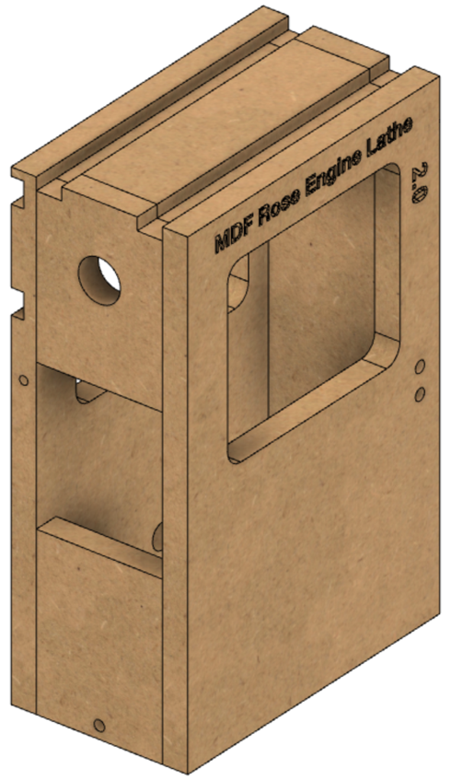Cutout these pieces as noted below. They are shown in the order I recommend pursuing.

**H5**

**H1**

**H2**

**H3**

**H5**

**H4U**

**H4L**

**H1**

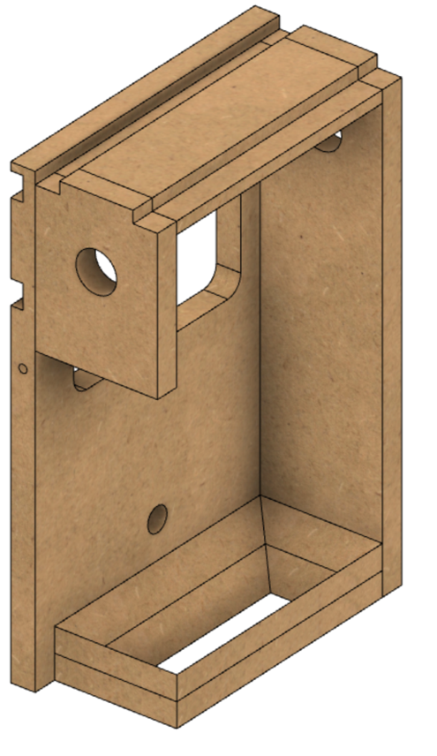

**H4U**

**H3**

**H2**

**H6U**

**H6L**

## Before Assembly

The following instructions should be followed before assembling the headstock.

### A close up of a piece of paper Description automatically generatedH1 – Side Closest to the User

**9 ½”**

**6 ½”**

For the window in the

**1 ½”**

piece, most machines

I’ve seen have radiused corners. That tends to look better but is not critical. The ½” radius is shown for an example.

**1 ½”**

The two holes marked for 11/32” (0.344”) are for the wedge block. They are tapped for 3/8”-16 threads.

**½” Radius**

**7 ½”**

**8 ¼”**

**5 ½”**

**NOTE** : DO NOT DRILL ANY OTHER HOLES INTO THESE PIECES AT THIS TIME.

**11/32” diam**

**11/32” diam**

**14 ½”**

### H2 – Side Furthest from the User

The cuts for the T-Track are shown in the side view (the left pic). These dimensions are critical as they put the T-Track centered at 1 ½” above and 1 ½” below the spindle’s center. The T-Track is set to be flush with the surface, and is designed to use T-Track which is ¾” wide x 3/8” tall.

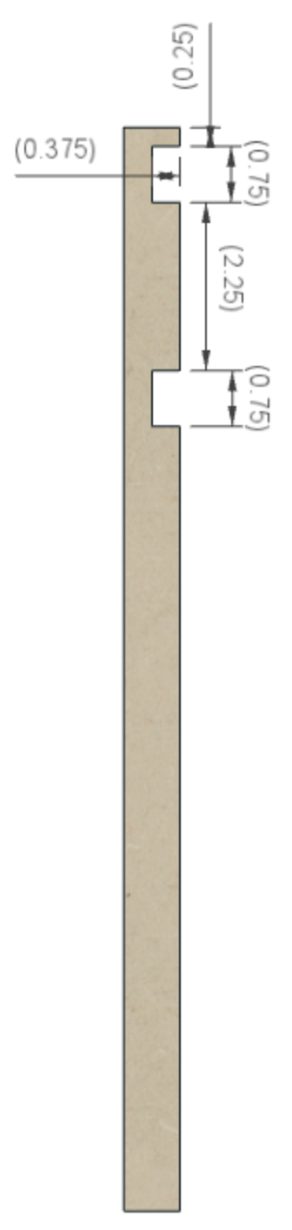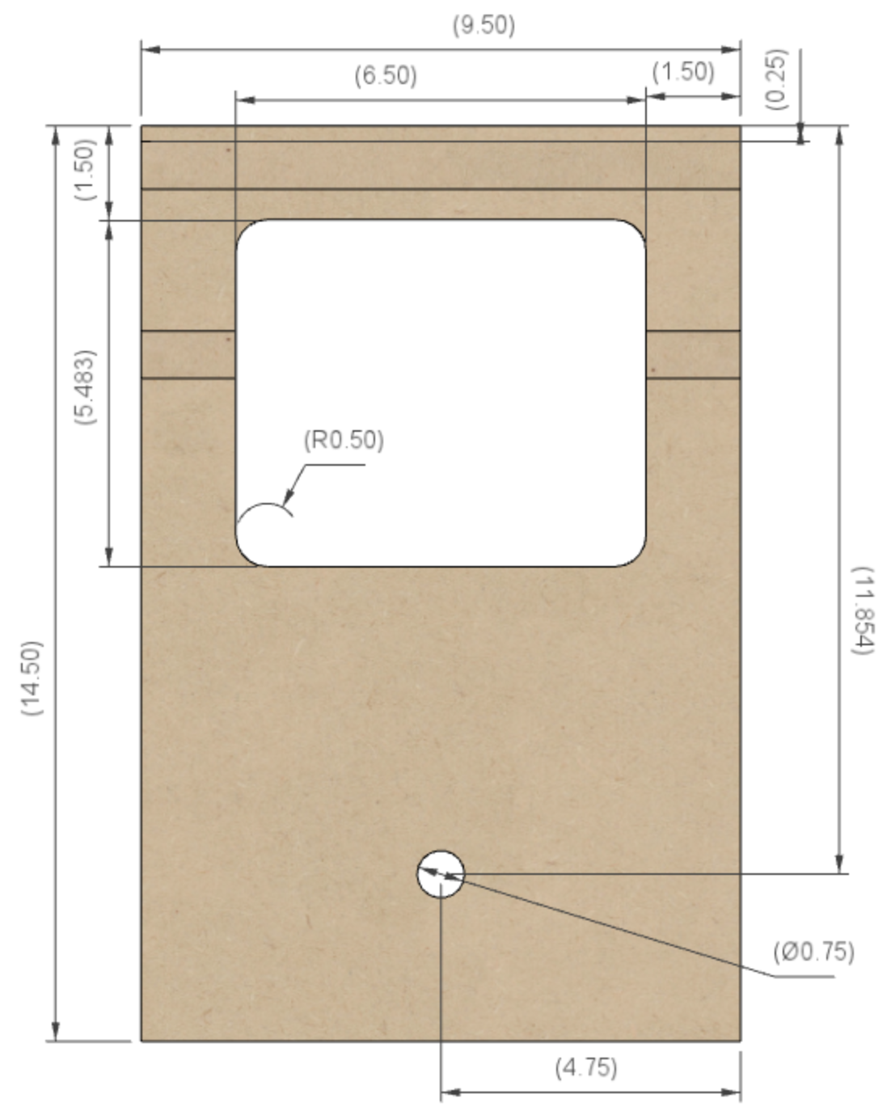As with **H1**, the window in the piece usually has radiused corners. That tends to look better but is not critical.

**4 ¾”**

**11 ⅞”**

**9 ½”**

**6 ½”**

**5 ½”**

**14 ½”**

**⅜”**

**¼”**

**2 ¼”**

**¾”**

**¾”**

**¼”**

**1” diam**

**1 ½”**

**1 ½”**

**½” Radius**

The 1” hole at the bottom is for the wires to pass thru from the stepper motor.

The dimension shown as 11 ⅞” could be less, and moving the hole up to around 11” may be a good choice. Don’t increase the distance much though as it could be covered up by the two bottom pieces (**H6U** and **H6L**).

**NOTE** : DO NOT DRILL ANY OTHER HOLES INTO THESE PIECES AT THIS TIME.

### Headstock Pivots

The layout of the headstock pivots, and how they fit into the various pieces of MDF are outlined below. Both sides are the same (just mirror images), so only one is detailed.



**H4L**

**B3**

**B4**

**H3**

The assembled components will look like the image below when in place.

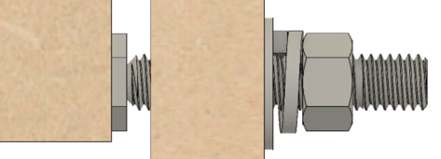

**H3**

**B4**

### A picture containing clock Description automatically generatedH3 – Right Side

**⅜”**

**¾”**

**1 ⅞”**

Drill the top and bottom holes whilst the fences are setup on the drill press. As noted in the section on **Accuracy** (pg. 4), the alignment of these two holes on both ends is critical.

**2 ⅛”**

**Note 1**: The diameter of the hole at the top should match the bronze bushing. It is shown here as 1 ½”, but size it to fit your bushings.

**1 ½” Diam**

The indentations at the top are designed to use T-Track which is ¾” wide x 3/8” tall.

The hole marked for drilling 5/16” at the bottom is for the pivot.

The 5/16” hole will be tapped for a 3/8"-16 thread. This is where you will use the 3/8"-16 x ¾” Bolt Head Thinned to 0.125" with a 60° Recess.

**14 ½”**

**NOTE** : DO NOT DRILL ANY OTHER HOLES INTO THIS PIECE AT THIS TIME.

**⅜”**

**1 ⅞”**

**3 ¾”**

**5/16” Diam**

### A picture containing clock Description automatically generatedH4 – Left Side

**⅜”**

**1 ⅞”**

**¾”**

As with **H3**, drill the top and bottom holes whilst the fences are setup on the drill press. As noted in the section on **Accuracy** (pg. 4), the alignment of these two holes on both ends is critical.

**2 ⅛”**

**H4U - Top Piece**

**1 ½” Diam**

**Note 1**: As noted above for **H3**, the diameter of the hole at the top of H4 should match the bronze bushings you have.

**5”**

The indentations at the top are designed to use T-Track which is ¾” wide x 3/8” tall.

**Gap Between the Two Pieces**

The 4 ½” gap shown is needed for the stepper motor. Even if you are going to use a hand-crank, I recommend you build it this way. It makes the changeover easier later if you do decide to go that way.

**4 ½”**

**H4L - Bottom Piece**

The hole marked for drilling 5/16” at the bottom is for the pivot.

**5/16” Diam**

The 5/16” hole will be tapped for a 3/8"-16 thread. This is where you will use the 3/8"-16 x ¾” Bolt Head Thinned to 0.125" with a 60° Recess.

**5”**

**⅜”**

**NOTE** : DO NOT DRILL ANY OTHER HOLES INTO THIS PIECE AT THIS TIME.

**1 ⅞”**

**3 ¾”**

### H5 – Top

**3 ¾”**

The top piece fits into the rectangle made by pieces **H1, H2, H3,** & **H4U**.

**¾”**

**¾”**

Jon’s instructions noted to wait on cutting this piece’s length (shown to the right as the 8” side), and then cut it down to fit into the hole. That is a good idea. But, for sake of completeness, the estimated size is below.

The width (shown to the right as the 3 ¾” side) is not an issue as it is the same as **H3** & **H4**.

The drawing at the right is the top view, and the drawing at the bottom of the page is the side view.

The cuts for the T-Track are shown in the side view (the bottom pic). These dimensions are critical as they put the T-Track centered at 1 ½” left and 1 ½” right of the spindle’s center. These are designed to use T-Track which is ¾” wide x 3/8” tall.

**8”**

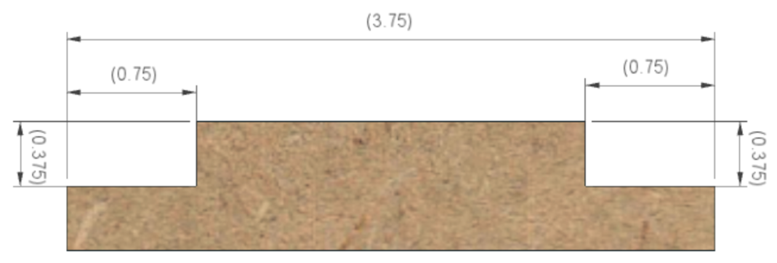

**¾”**

**¾”**

**¾”**

**¾”**

**3 ¾”**

### A picture containing building, brick, sitting, small Description automatically generatedH6U & H6L – Bottom

**3 ¾”**

The bottom consists of two pieces. This is a modification from the way the original MDF Rose Engine lathe was built.

The cut in these forms a “funnel”, allowing saw dust to fall thru the bottom of the headstock. This makes it easier to keep it cleaner over time.

The reason two pieces are used is to ensure the rigidity of the headstock when in use, as rigidity is necessary for the quality of the cuts.

The outside dimensions are shown to the right. These are often sized after the other pieces are put into place, but the sizes of 8” x 3 ¾” are a good starting point. The picture to the right shows these when viewed from the top.

**8”**

**H6L**

**H6U**

If these two pieces were cut crosswise, you would see the angles on the inside as shown below. This makes the funnel shape.

It is noted here is 45°, but this angle is not critical (that is what was used for the CAD modelling).

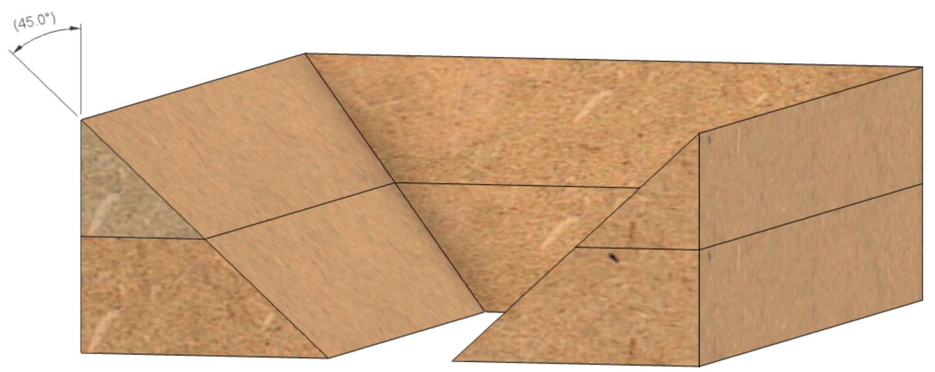

**45°**

**45°**

**H6U**

**H6L**

.

## Assembly of the Headstock

The next set of instructions should be followed for the assembly of the headstock.

### Prior to Assembly of the Headstock

Shellac, wipe-on polyurethane, and paint are all typical, and simple finishes for MDF. If you want to finish your lathe, now is a good time to paint the inside of the pieces. Finishing the inside of the headstock is difficult to do after the parts are assembled.

### Assemble the Headstock

Dry fit the pieces, and then cut **H5** and **H6** as necessary to fit.

**Notes :**

1. When assembling the pieces, it is best to use the spindle and bushings to align **H3** and **H4.** These can be inserted into the holes that were drilled.

1. Jon recommends these be assembled using biscuits or dowels. Either way your alignment is greatly aided

Once you are satisfied, glue the pieces together, and clamp them. Yellow glue works well.

## After Assembly

After the headstock is assembled, you are still not complete. The instructions below should be followed.

### Headstock Tensioning Bungee

The headstock is pulled towards the Rubber Support column (part of B3) using a bungee cord (the red cord in the picture below – though your bungee’s cord color may differ). The wooden block is held in place on the Rubber Support column (part of **B3**) by the T-Track on the side next to **A1A**.

### Headstock Bungee Mount

The button used for the bungee cord to pull against the headstock is shown to the left (the little white button circled in red). This needs to be attached ½” down from the top and centered horizontally.

**Headstock Tensioning Bungee**

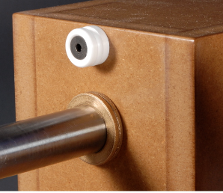

**Headstock Bungee Mount Point**

### Stepper Motor Mounting

The stepper motor drive (shown to the right) is a great upgrade.

The bracket used to hold the stepper motor and tension the belt is shown to the right as the metal piece outlined in red.

### H1 & H2

You will need to drill holes in **H1** and **H2** as shown below (the holes with red circles around them).

The holes marked for ¼” and 13/32” (on the next page) are for the stepper motor mount. They are not needed if you build your machine for hand-cranking.

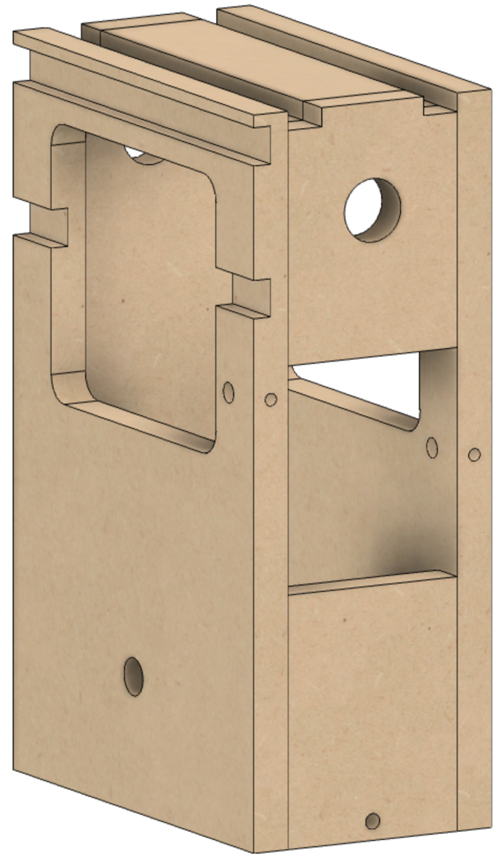The 13/32” (0.40625”) and ¼” holes need to be aligned: Front and side of **H1**, and the same on **H2**.

They are used for the furniture assembly crews like the ones shown below.

**Stepper Motor Mounting Bracket**

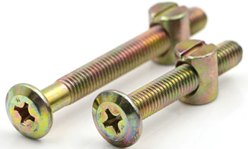

**Note 1**: The vertical position for the hole drilled in H1 (on the right side of the picture below) needs to be set based on alignment using the stepper motor bracket.

**Typical Furniture Assembly Screws**

**¼’ Diam**

**5 5/8”**

**5 5/8”**

**1”**

**¼’ Diam**

**H4U**

**H1**

**H2**

**H4L**

**5/16” Diam**

**H2**

**H1**

**5/16” Diam**

# Lathe Base Instructions

The next of instructions are for building the base. The base is these pieces:

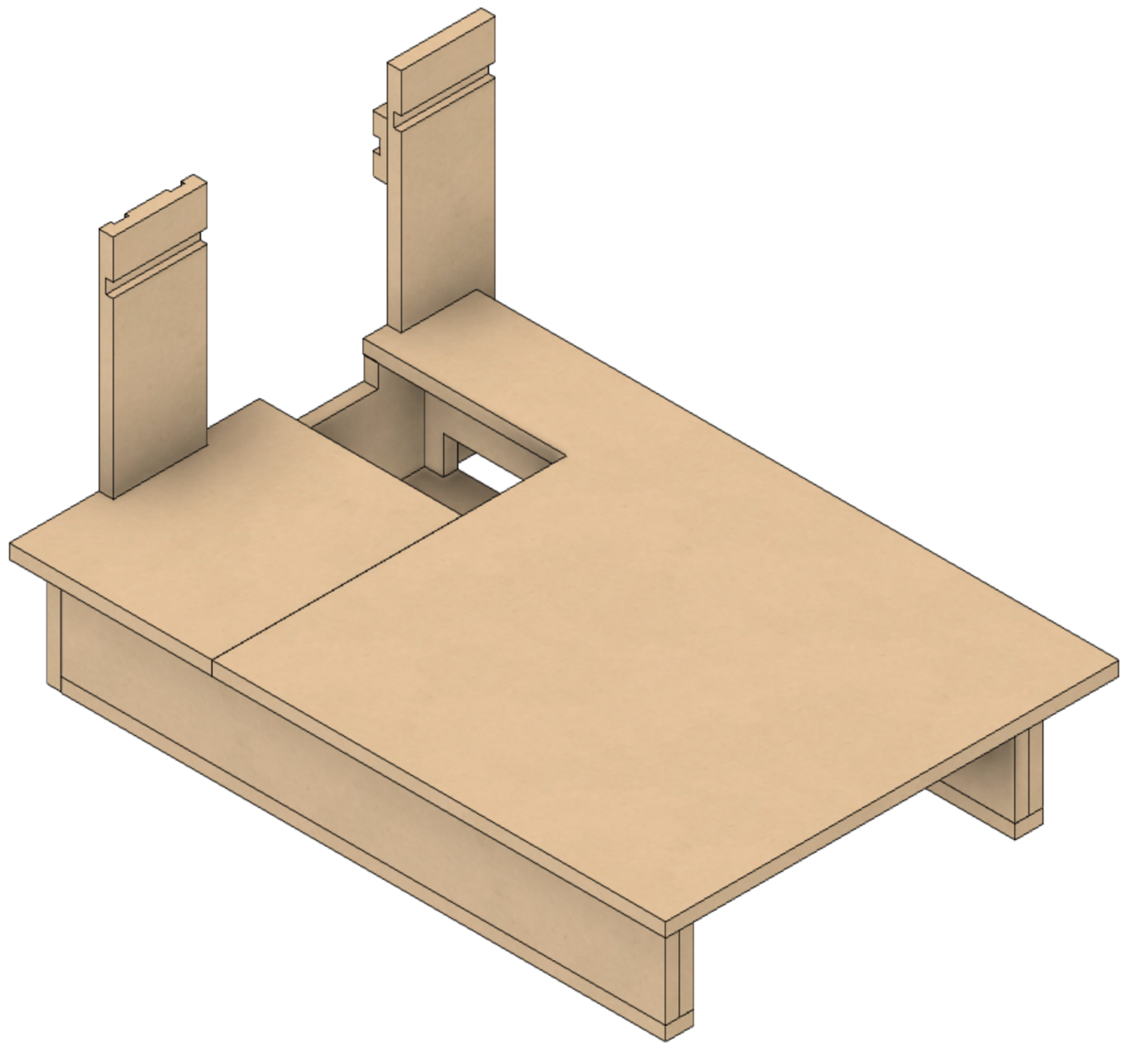

**B1**

**B1A**

* **B1** – The main part of the bed of the lathe.
* **B1A** – The remainder of the bed of the lathe. (This area is often used for storing tools, so it is separated off from **B1**.)

Removing **B1** and **B1A**, we have the picture on the next page. The remainder of the parts are described there. The other base pieces are:

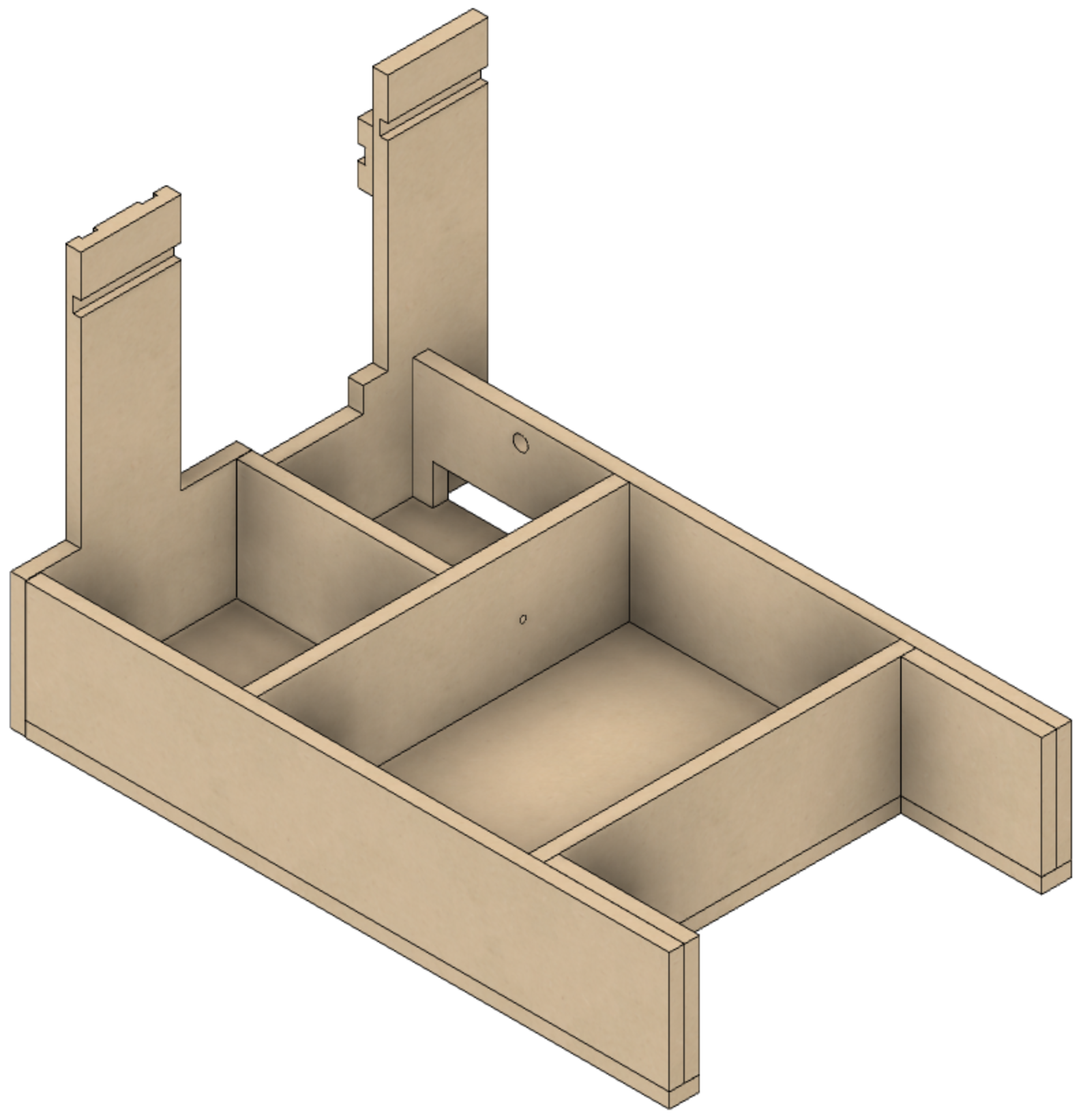

**B3**

**B8**

**B7**

**B6**

**B2**

**B4**

**B5**

**B9**

**B10**

**RS2**

* **B2** – The bottom.
* **B3** – The left side.
* **B4** – Left side support for **A1**, and mount for the headstock pivot point.
* **B5** – In the old MDF Rose Engine, this was the right side. This was pushed back to accommodate a cutout under the bed to place the controls for the stepper motor(s).
* **B6** – The rear side.
* **B7** – Back side to support the box area in front of the headstock. Also supports the **A1A** piece.
* **B8** – The front.
* **B9** – Additional support for stability for the front of the lathe’s bed (**B1**).
* **B10** – Additional support for stability for the back of the lathe’s bed (**B1**).

## Before Assembly

These instructions should be followed before assembly of the base.

### B1 – Lathe Bed

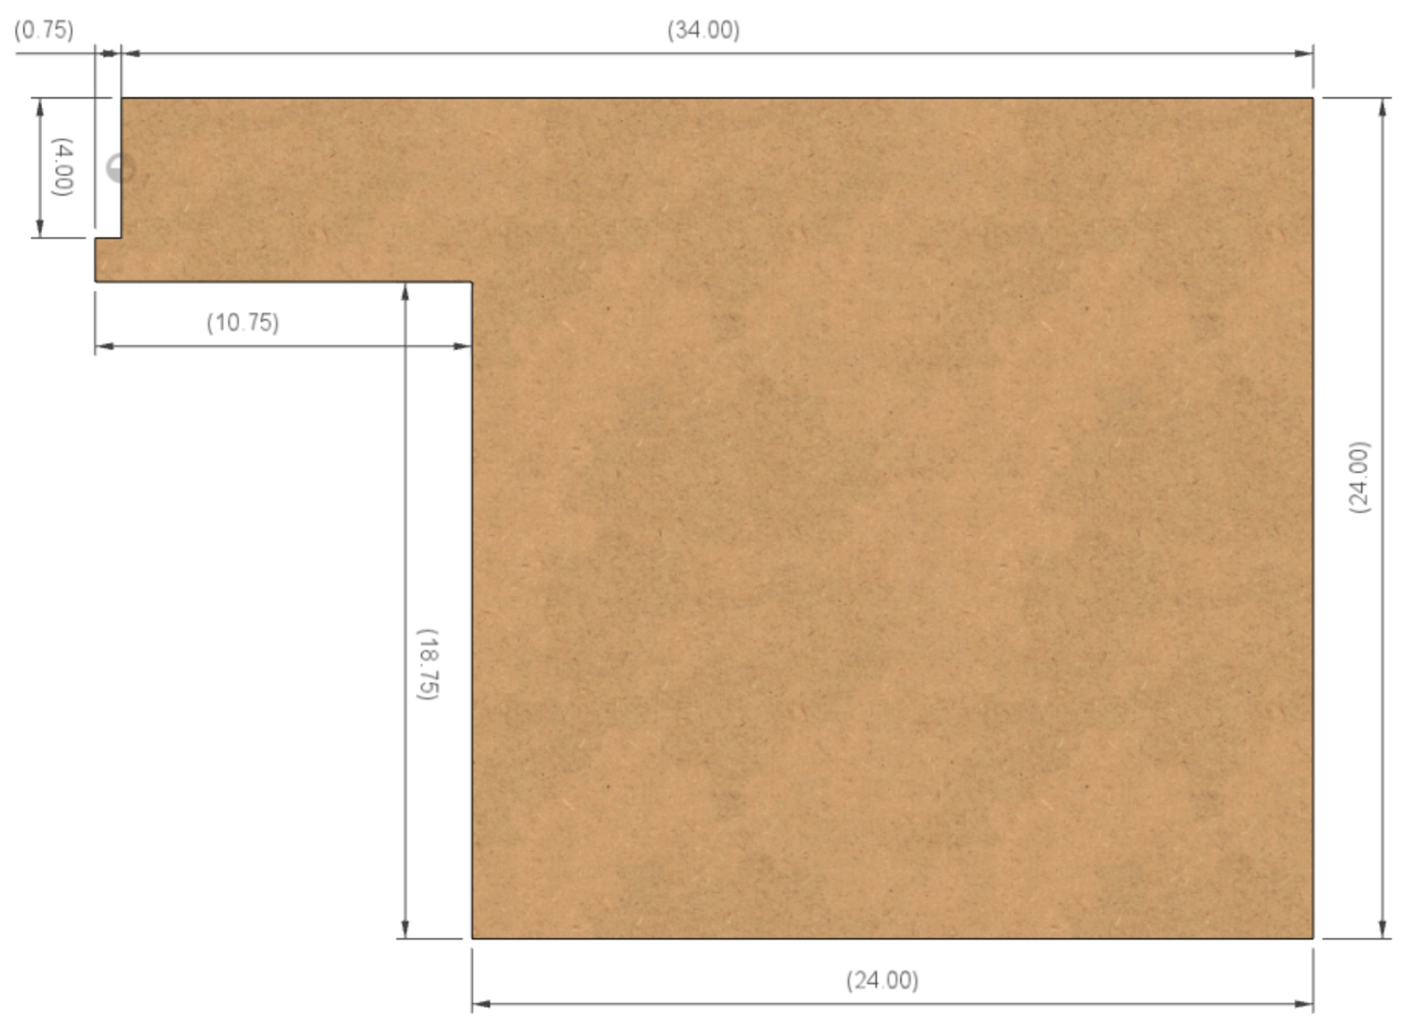

**¾”**

**34”**

**24”**

**24”**

**18 ¾”**

**10 ¾”**

**4”**

The size of **A1** allows for putting a 24” x 24” piece of sheet metal on the top. The minimum thickness sheet that is 16 gauge (1/16”) thick, though 1/8” steel is recommended by some. Don’t use aluminum: the metal must be ferrous to allow the MagSwitches to bind to it.

**Option:** One option that has been proposed is to make B1 a square, 24” x 24”. This can be done; however, I found that the area behind the headstock is useful for holding a task light (like shown to the left). And, in the MDF Rose Engine Lathe 2.0 design, the back (**B6**) is not as close to the headstock, so the spacing block would have to be re-designed.

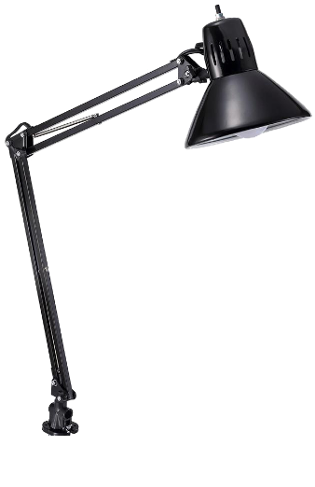

**B1A**



**B1**

### B1A – Lathe Bed

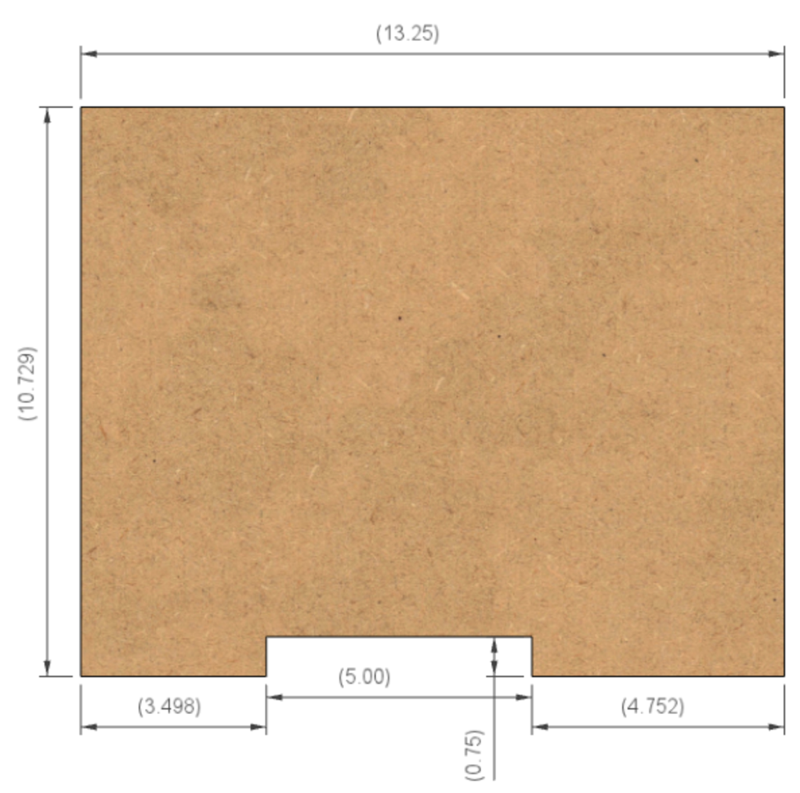

**13”**

This piece covers the area that had been used for the hand crank. With a stepper motor, this is not necessary.

Making a cover for this area allows it to be used for the electronic parts for the stepper motor(s).

**5”**

**¾”**

**10 ¾”**

**3 ¼”**

**4 ¾”**

### B2 – Lathe Bottom

**32”**

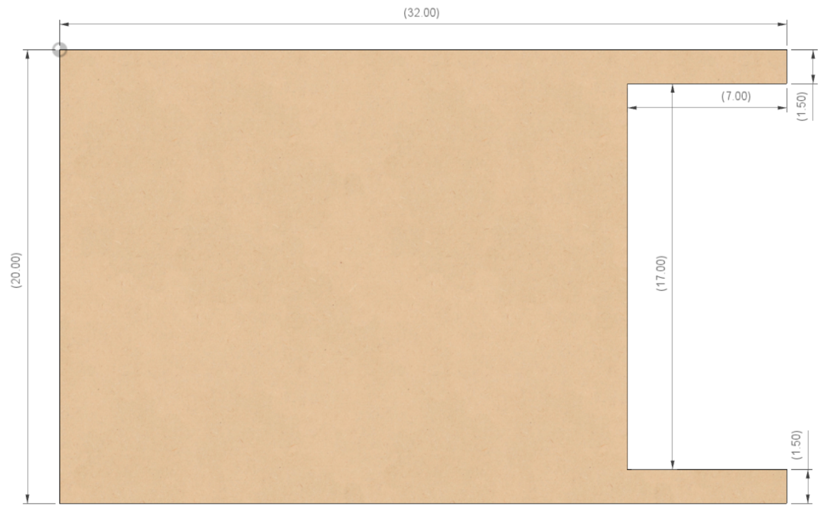

**1 ½”**

**1 ½”**

**7”**

**17”**

**20”**

### B3 – Left Side

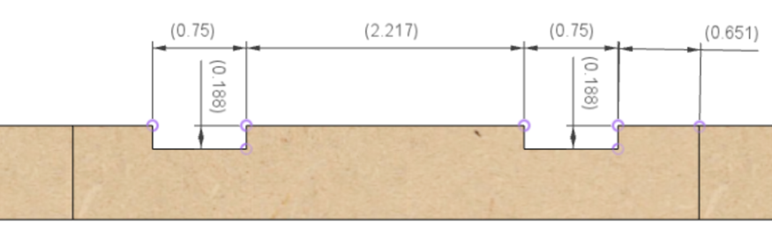

**¾”**

**¾”**

The cuts for the T-Track on this side are shown in the top view (the top pic). The T-Track is set to be proud of the surface, 50% (3/16”) below it and 50% (3/16”) above. This is designed to use T-Track which is ¾” wide x 3/8” tall.

**5/8”**

**2 ¼”**

**3/16”**

**3/16”**

These T-Tracks are used by the **RS-1** rubber support.

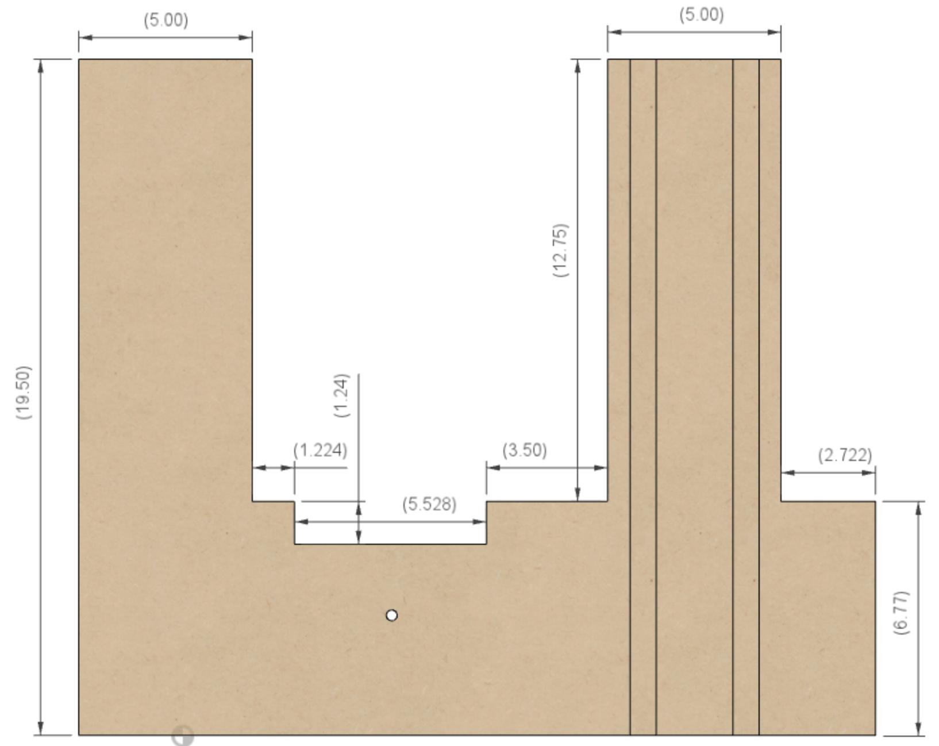

**2 ¾”**

**6 ¾”**

**12 ¾”**

**19 ½”**

**3 ¼”**

**5 ½”**

**1 ¼”**

**1 ¼”**

**5”**

**5”**

The cuts for the T-Track on this side are shown in the side view (the right pic). The T-Track is set to be flush with the surface. This is designed to use T-Track which is ¾” wide x 3/8” tall.

These T-Tracks are used for the headstock bungee.

**3 ½”**

**9”**

**2”**

**2”**

**¾”**

**¾”**

**3/8”**

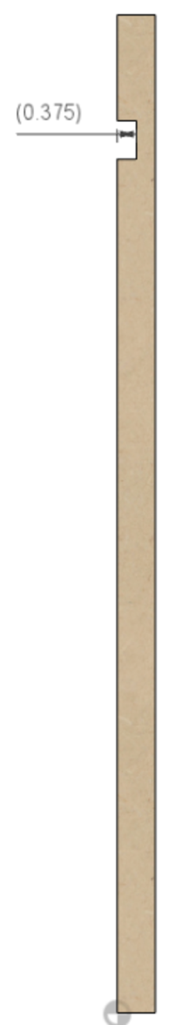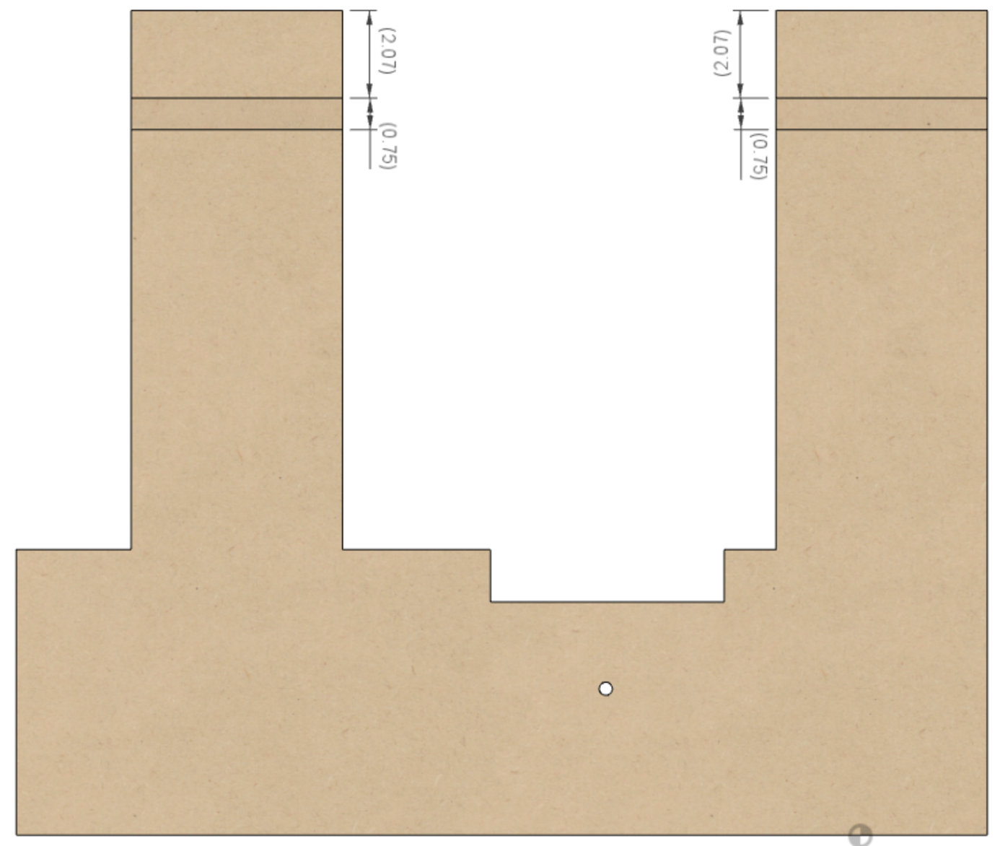

A hole is needed in **B3** for the headstock’s pivot point (see also, picture below). This hole is for the T-nut. The T-nut is used to hold the adjustable pivot for the headstock to rock on.

The flange of the T-nut should be on the inside of the base, facing the **B4** side (see also, the picture below).

1. Counter-bore for the T-nut. The goal is to set the T-nut flush with the MDF. Measure the OD of your T-nut and the flange thickness, then counter-bore **B3** from face that will be facing towards the headstock. A typical 3/8”-16 T-nut will have an OD of 1” and a flange about 1/16” thick.
2. Also measure the body of the T-nut and counter-bore for that next. Typical T-nuts will need a 29/64” drill for the body, about ½” deep.
3. Finally drill through with a 25/64” drill for the 3/8” pivot screw to pass through.

### 

**View from the Back, Looking Towards the Front**

### B4 – Inside

**18 ½”**

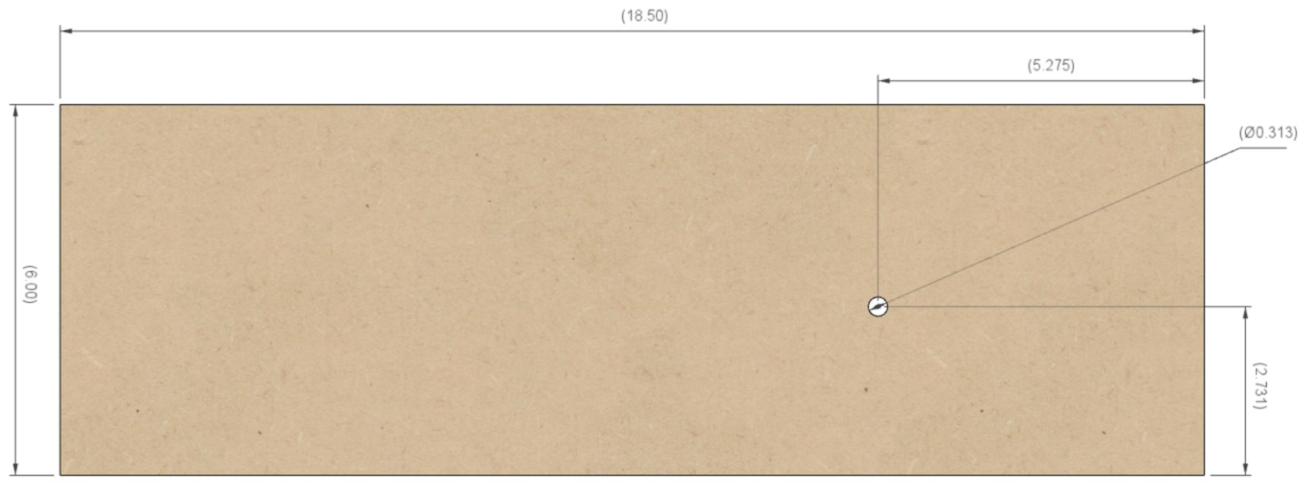

**(see notes)**

**5 ¼”**

**2 ¾”**

**6”**

A hole is needed in **B4** for the headstock’s pivot point. The instructions for this hole are the same as for **B3**, with the exception that the flange for **B4** is facing the **B3** side (see also, the picture below).

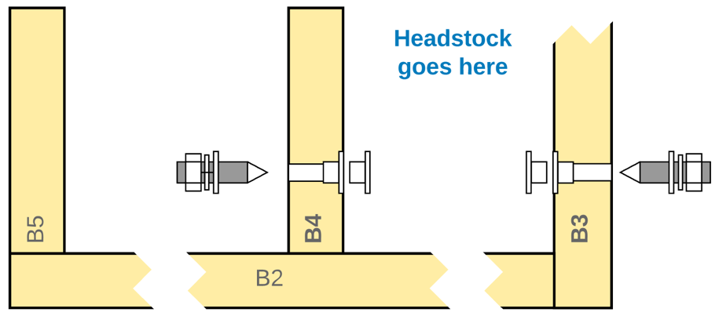

**View from the Back, Looking Towards the Front**

### B5 - Inside

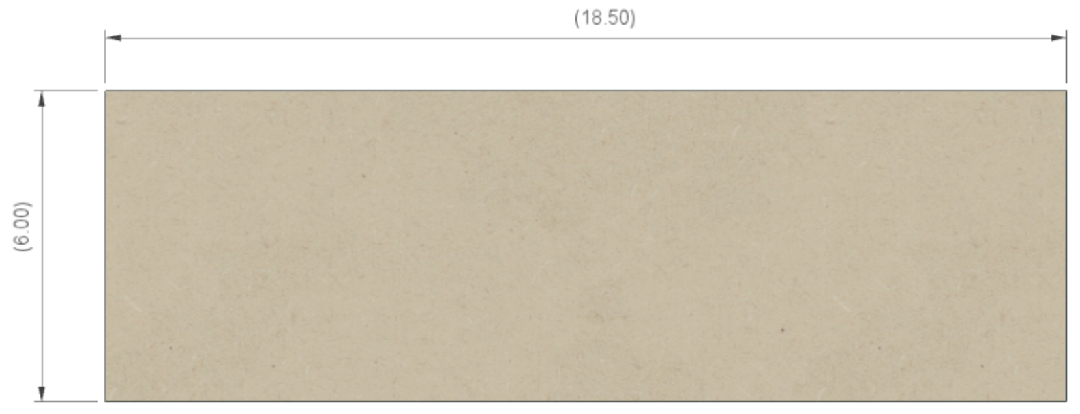

**6”**

**18 ½”**

### B6 - Inside

**1” diam**

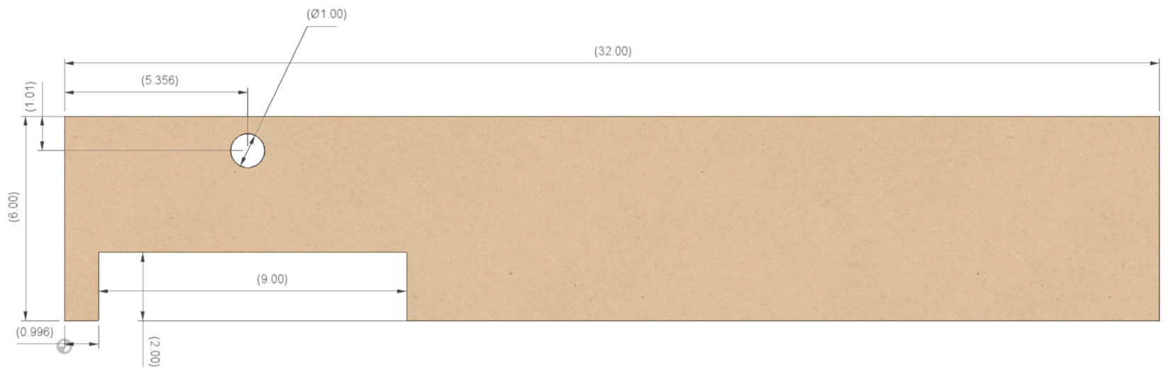

**5 3/8”**

**2”**

**1”**

**9”**

**32”**

**1”**

**6”**

### B7 - Inside

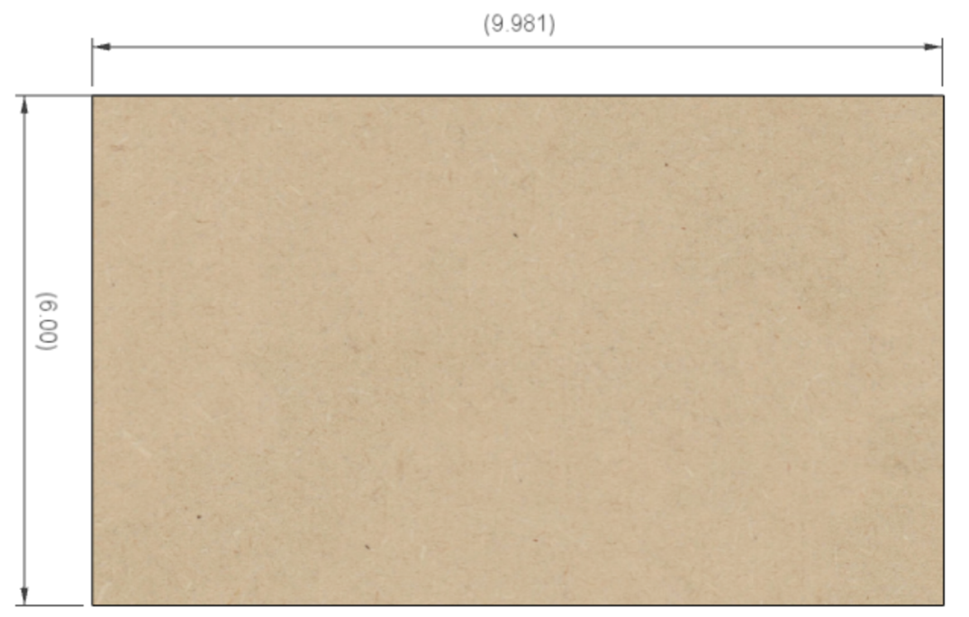

**10”**

**6”**

### B8

I chose to not put the openings in this piece, though you can if you wish.

**32”**

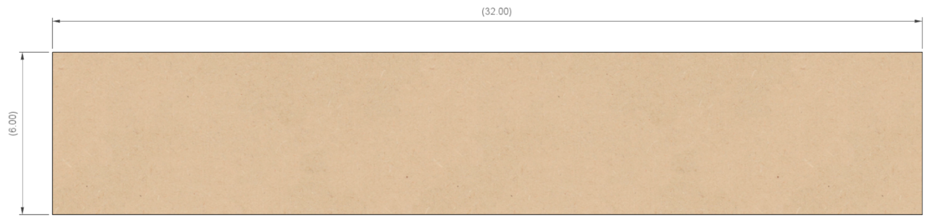

**6”**

### B9 & B10

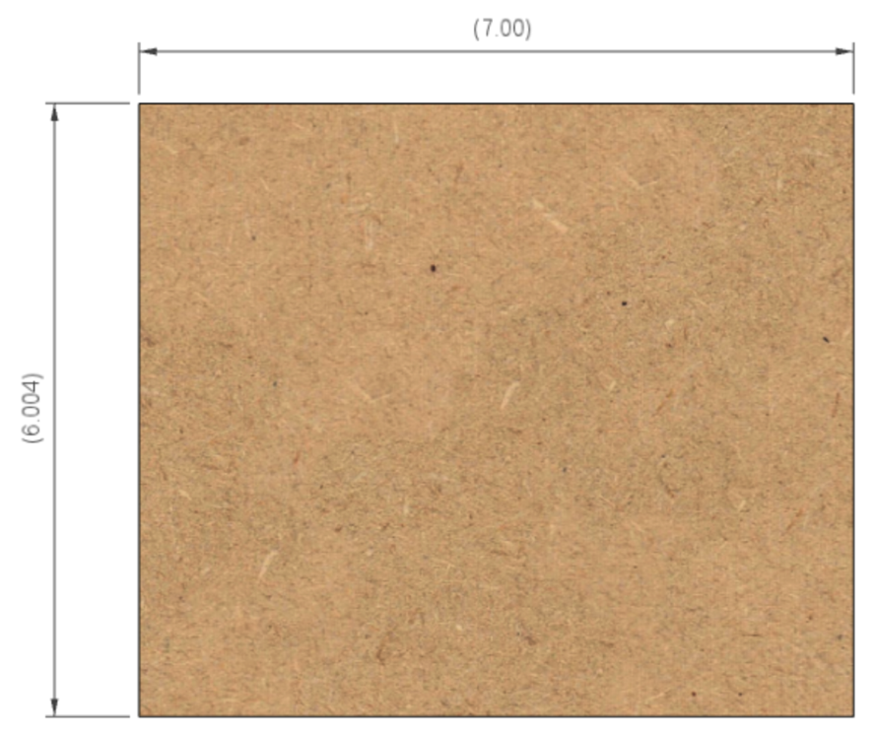

**6”**

**7”**

## Rubber Support

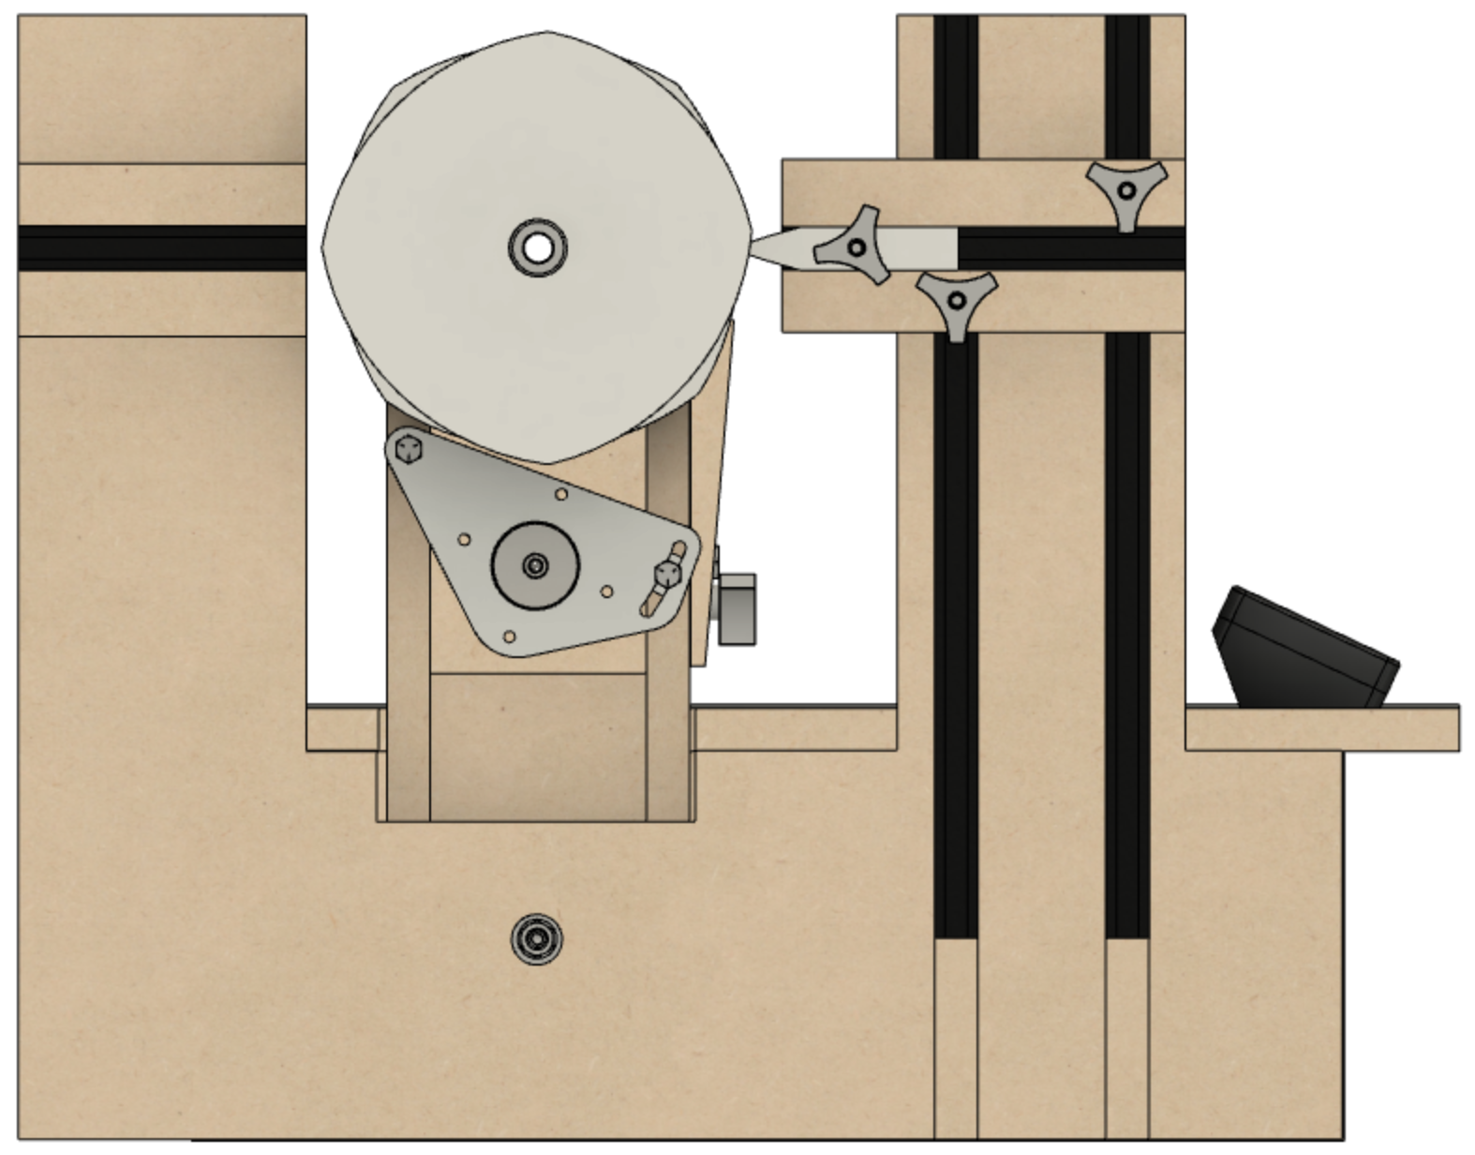The rubber support columns on **B3** have two blocks that are used to position the rubber(s).

**B3**

**RS1**

**RS2**

### A piano in a room Description automatically generatedRS1 – Front Rubber Support

**RS1** is used to hold the rubber and allow for rubber to be moved in or out (relative to the spindle), and up or down. The vertical alignment of the front rubber allows for the use of an amplitude adjuster. For the vertical alignment, **RS1** rides on the T-Track. The overlap of the T-Tracks is shown in the picture to the right.

**A1A**

**B3**

**RS1**

**Top View – Showing RS1 Installed**

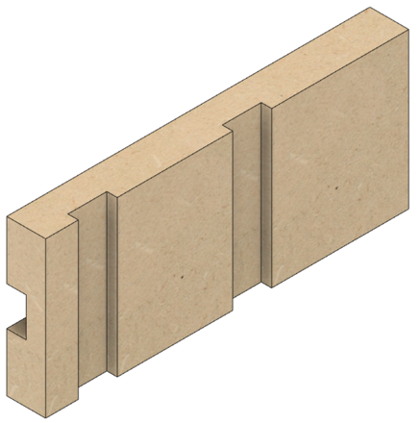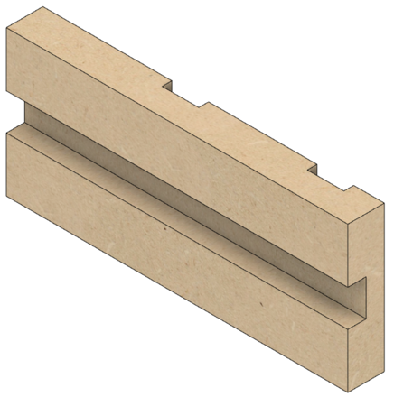

**Left Side of RS1**

**Right Side of RS1**

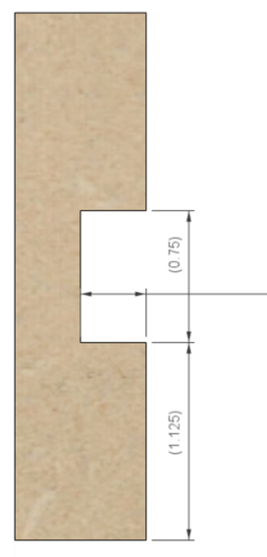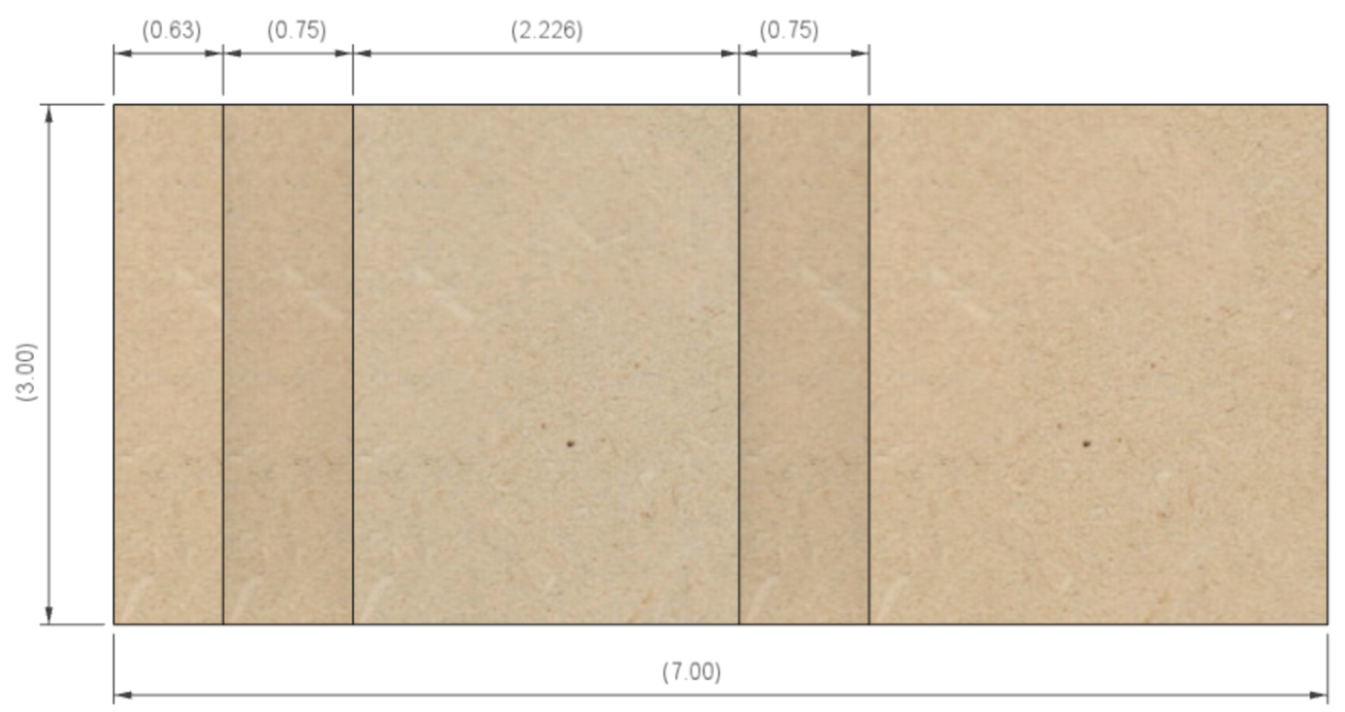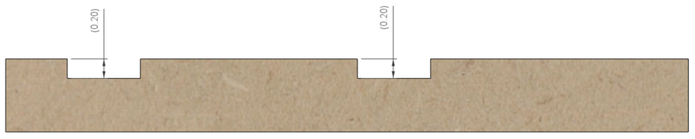

**¾”**

**¾”**

**5/8”**

**¾”**

**1 1/8”**

**3/8”**

**¾”**

**2 ¼”**

**3”**

**7”**

**3/16”**

**3/16”**

### RS2 – Rear Rubber Support

**RS2** is used to hold the rubber and allow for rubber to be moved in or out (relative to the spindle). (There is no amplitude adjuster available for the rear rubber support.)

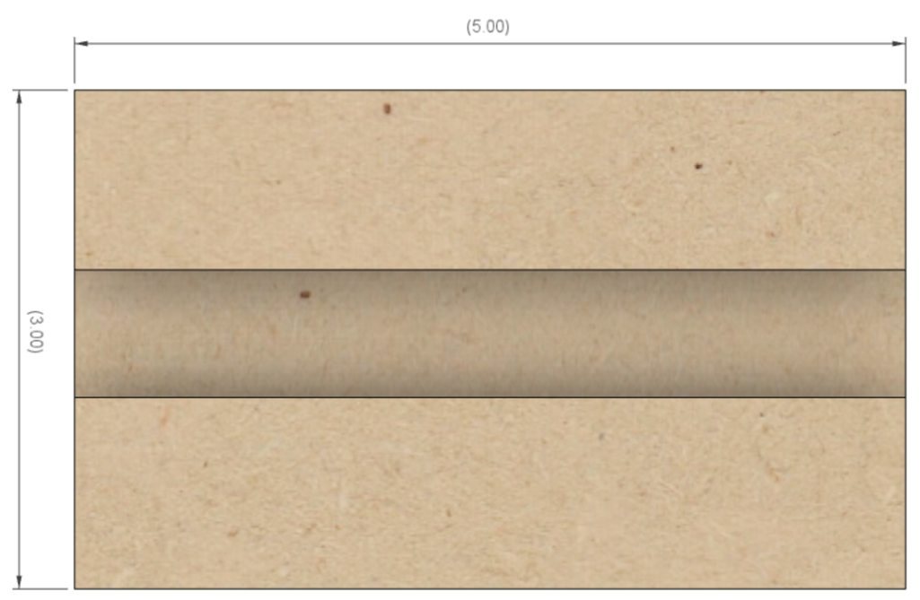

**5”**



**3”**

**¾”**

**3/8”**

**1 1/8”**

## Assembly of the Base

Assemble the pieces of the base, gluing them together and clamping them. Do not install **B1** nor **B1A** at this time.

## After Assembly of the Base

Once everything is in place, install the headstock. Secure it in place by tightening the Pivot Set Screws. Secure them in place using the nuts.

Now it is time to install B1 and B1A. Do not glue **B1** or **B1A** to the other pieces.

* **B1** is screwed into place
* **B1A** sits on supports or screwed into place.

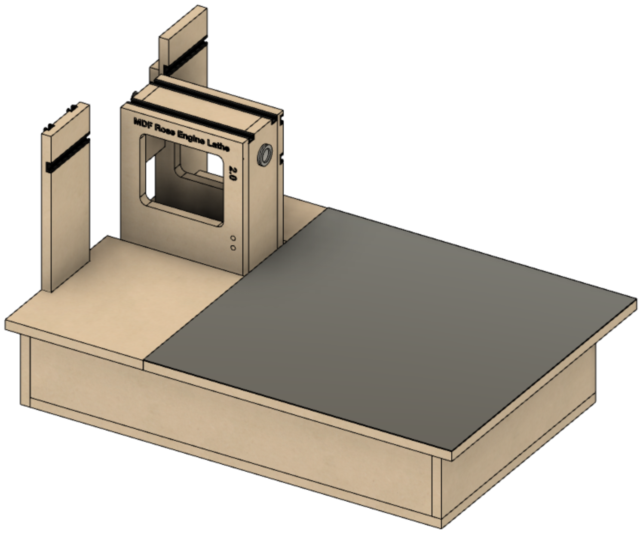Attach a sheet of steel to the top of B1 as it allows for the use of magnetic switches (shown to the left) to secure the cross slide in place wherever needed.

The steel sheet can be attached with two screws on the top edge. No more than two should be used as the metal will expand and contract with temperature changes, and this will be different than the movement of the MDF wood.

An alternate is to use MagSwitches on the bottom of **A1** to hold the steel sheet down.

**Steel Sheet**

# Cross Slide Base Instructions

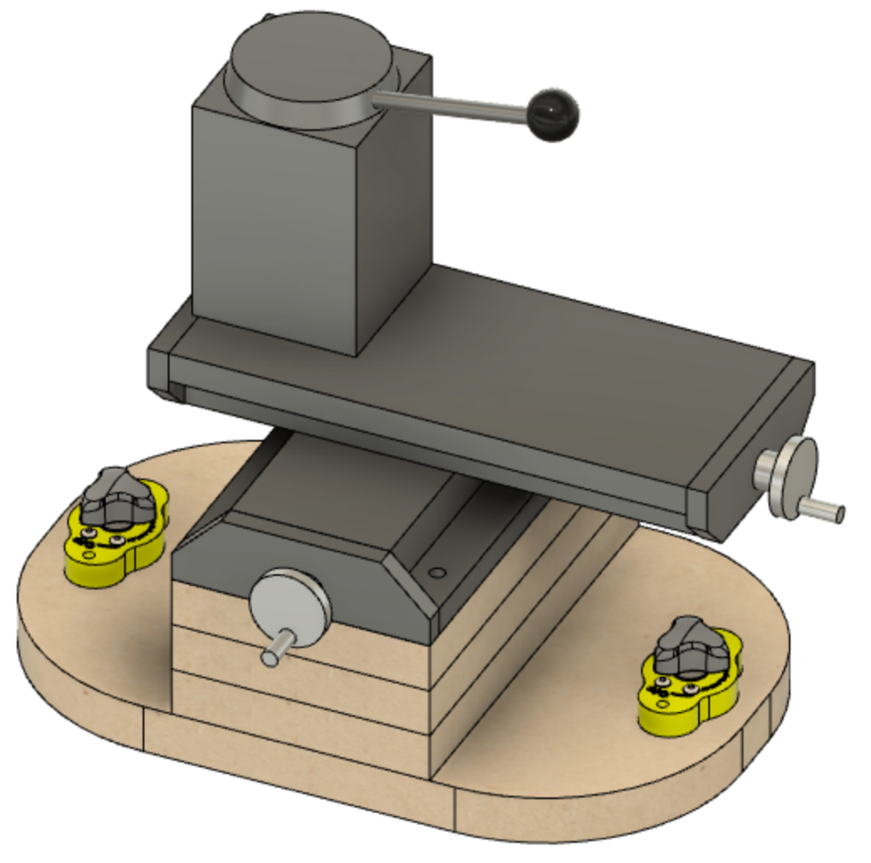The Cross Slide needs to be mounted to a base which enables it to be secured to the steel sheet covering the lathe base (on **A1**).

MagSwitches on each end hold the base secure to the steel sheet.

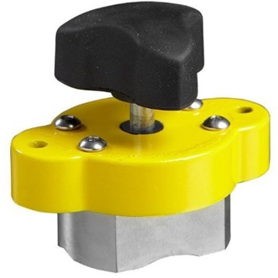

**MagSwitch**

### CS1 – Bottom

The bottom, **CS1**, is as below.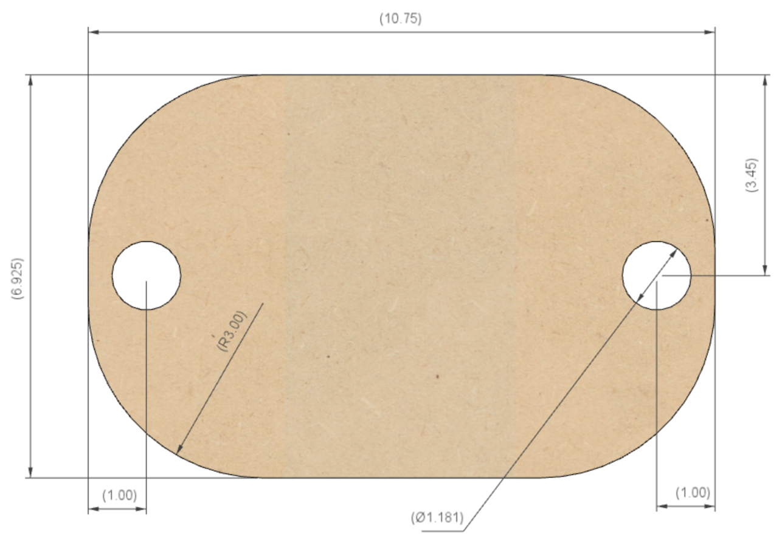 The corners on mine are rounded off with a 3” radius on each of the 4 sides. This is not critical but gives it a nice look.

**3” Radius**

**30mm Diam**

**10 ¾”**

**7”**

**3 ½”**

**1”**

**1”**

The 30mm holes on each end are for MagSwitch 95s. If using MagSwitch 150s, this would be 40mm.

### CS2, CS3, & CS4

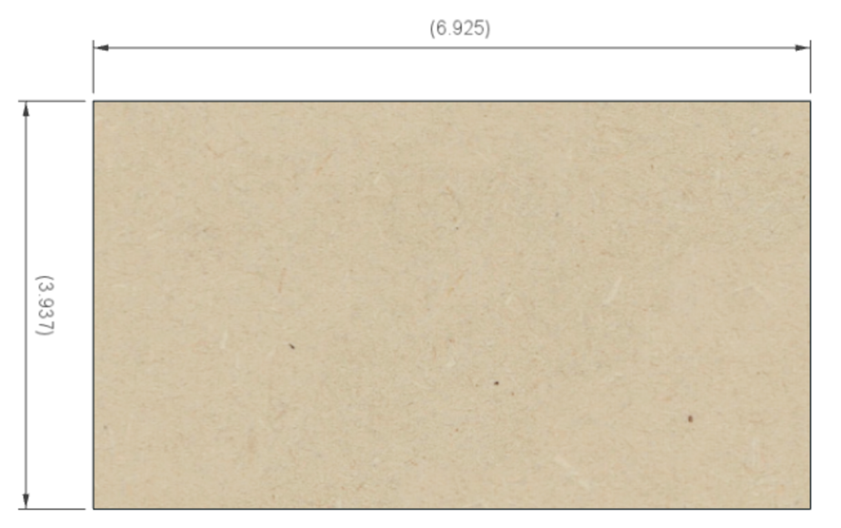There are 3 pieces used to elevate the cross slide to the proper height: CS2, CS3, and CS4

**7”**

**4”**

## Drilling Holes and Assembly

The holes that need to be drilled in these pieces is noted below. Start with **CS1**.

1. Drill the 30mm holes first. These are for the MagSwitches (picture on previous page). It is a good idea to set them in the holes and then drill small pilot holes on the sides for the screws (or nails) needed to hold the MagSwitches in place.
2. 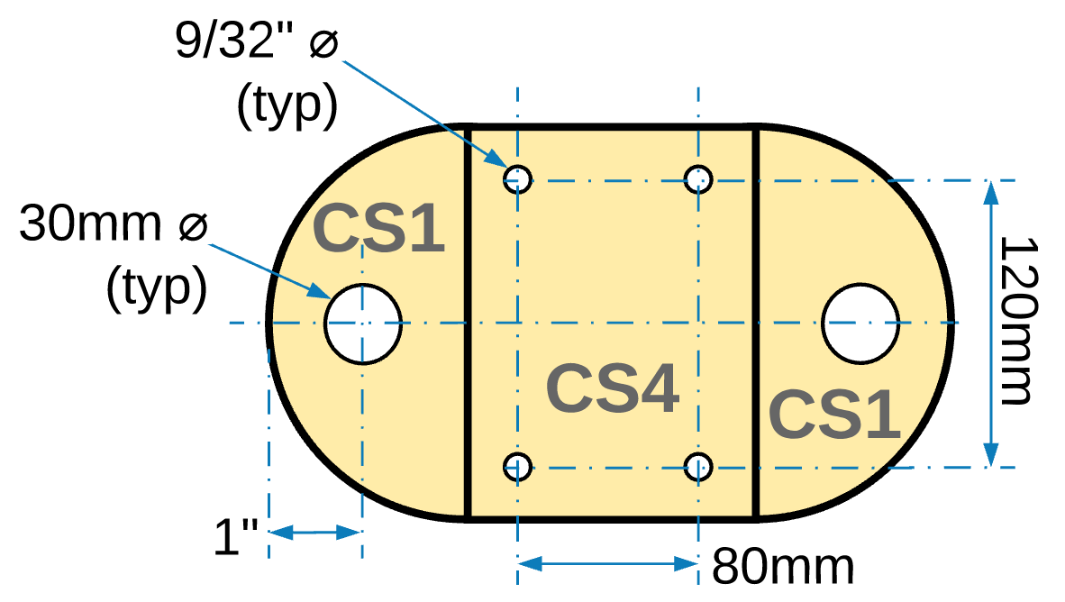Next, drill the 3/4” recesses on the bottom of **CS1**. These need to be deep enough to ensure that the bolt heads do not project down below the surface of the wood. 3/4" was selected to allow the bolt to be held by a socket. Depending on your socket’s size, these may need to be larger.   
     
   The centers for these holes need to be aligned according the fastening holes for the cross slide. The one from LittleMachineShop, part # 2008, has holes spaced at these dimensions. Ensure they match the cross slide you have selected.  
     
   These ¾” holes are drilled first as the points on the Forstner bit will leave a small divot which will be used for centering the next holes to be drilled.
3. Holding all 4 pieces together, drill the first 9/32” hole through all 4 pieces. Insert one bolt and snug it down.

**Top View**

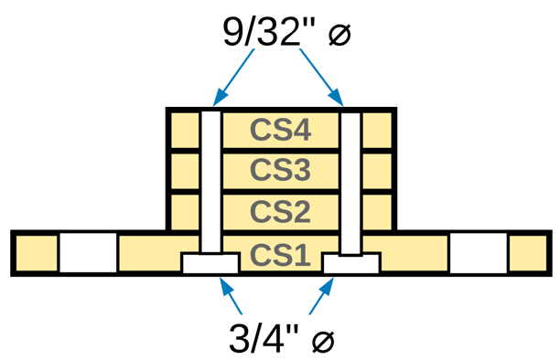

1. Drill the hole in the opposite corner and insert a second bolt and snug it down.
2. Drill the remaining 2 holes.

**Side View**

To the extent that material may appear to be infringed, we assert that such alleged infringement is permissible under fair use principles in U.S. copyright laws. If you believe material has been used in an unauthorized manner, please contact me at [ColvinTools@Gmail.com](mailto:ColvinTools@Gmail.com).

Portions of this document are copyrighted by Jon Magill and are used with his permission.

Permission is not granted to manufacture these for sale.